Taisto Suutari
Katera Steel Oy
16.07.2026 HP11257-3

PRICE OFFER

Project: Pedestrian Steel Skybridge - Kotka CAM (2E500) - Easpring
Project address: Keltakalliontie 27, 48770, Kotka, Finland
Price offer is calculated according to IFC model and drawing received on 15.07.2026 from Taisto Suutari <taisto.suutari@katerasteel.fi>.

PRICE, EUR VAT 0%
1. Pedestrian Steel Skybridge
No. | Name | Paint system | Amount | Unit | Price, € | Unit price
1. | Steel constructions manufacturing |  | 206 414 | kg | 576 885
1.1 | WI columns | C3.07 | 72 143 | kg | 222 073 | 3,08
1.2 | WI beams | C3.07 | 40 264 | kg | 99 130 | 2,46
1.3 | Beams | C3.07 | 60 473 | kg | 154 949 | 2,56
1.4 | Bracings (horis.+vert.) | C3.07 | 22 389 | kg | 59 523 | 2,66
1.5 | Frame | C3.07 | 4 357 | kg | 12 820 | 2,94
1.6 | CFJ parts (delivered separately) | C3.07 | 755 | kg | 3 604 | 4,77
1.7 | Erection plates and support plates | C3.07 | 6 033 | kg | 24 785 | 4,11
2. | Transport:  - 10 pcs standard truck 2,4x2,6x13,5 m;  - 1 pcs special truck 2,4x2,6x20 m. |  | 1 | set | 14 400
 | TOTAL: |  |  |  | 591 285
Delivery time, Pedestrian Steel Skybridge:
- W32/2026 - start of fabrication and material purchasing
- W44-47/2026 – deliveries to site

Delivery terms: DAP Keltakalliontie 27, 48770, Kotka, Finland
Offer is valid: 07.08.2026

The price offer includes:
- Steel structures fabrication
- Surface coating as stated Price Tables above
- Surface preparation grade P2, EN ISO 8501-3
- Transport

The price offer does not include:
- Erection Works
- Workshop drawings
- Roofing sheets
- Fasteners
- Fire protection painting

ASSUMPTIONS AND REMARKS

- Workshop drawings
Workshop drawings delivered by client will meet the following conditions:
  - All workshop drawings will be in “pdf” and “dwg” format with all necessary dimension lines and info shown on drawings.
  - Tekla generated DSTV files for CNC manuf. machines will be delivered for cutting-drilling plates and profiles.
  - Part list, assembly-part list and assembly list delivered in Excel format
- Materials and fabrication
  - Materials, certificates, fabrication, quality inspection and anticorrosion protection according to EN standards.
  - Quality control and tracing of raw materials according to our ISO 9001 Quality manual.
  - Fabrication of the structural steel according to EN1090-2, execution class EXC2, tolerances acc. class 1.
  - CE marking will be issued by Maru Metall AS according EN 1090-1.
  - Splicing of plates and profiles has been assumed to be permitted.
  - Rectangular, square and circular hollow sections as shown in IFC models.
  - Steel grades S235JR, S355J2, S355J2H with 3.1 certificates. Steel according to EN10025, basic requirements, without options. Steel density for profiles 7,85.
  - If no detailed workshop drawings then we have assumed weld sizes for built-up profiles according to following table:
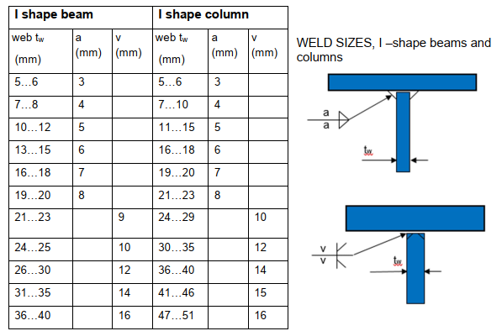
- Surface treatment in our workshop
  - Surface preparation grade P2, EN ISO 8501-3.
- Scope of erection
  - Erection works is not included in this offer.
- Transport and packing
  - Standard packing procedure of Maru has been assumed.
    - Large elements such as columns, main beams etc. will be transported loose – wooden dividers to be used.
    - Smaller elements such as beams, braces, wall elements etc. will be bound with stripes and stacked with dividers made of wood.
    - No special steel frames are used as packages.
    - Packing List according to Maru draft.
- Miscellaneous
  - We assume that maximum weight of single elements to be manufactured and lifted on site is ≤ 20 tons.
  - We assume that the possible contract will be a unit price contract i.e. the final accounts will be calculated by multiplying unit prices and actual quantities given in the final list of materials.
  - The following are excluded from the scope of the offer: non-carbon steel elements, bending of items, milling and machining.
  - The price offer does not reserve our production resources. Before the purchase order/contract, please coordinate the reservation of the resources.
  - Maru Metall reserves right to change prices if quantities, type of structures or technical demands will be changed.
  - Maru reserves the right to use subcontractors and partners.

Yours sincerely,

Madis Tuuling
Sales and Marketing Manager
+372 50 61 810
madis.tuuling@maru.ee

